**Will’s Mid Memes – April report**

CloudFront statistics

Cache Statistics

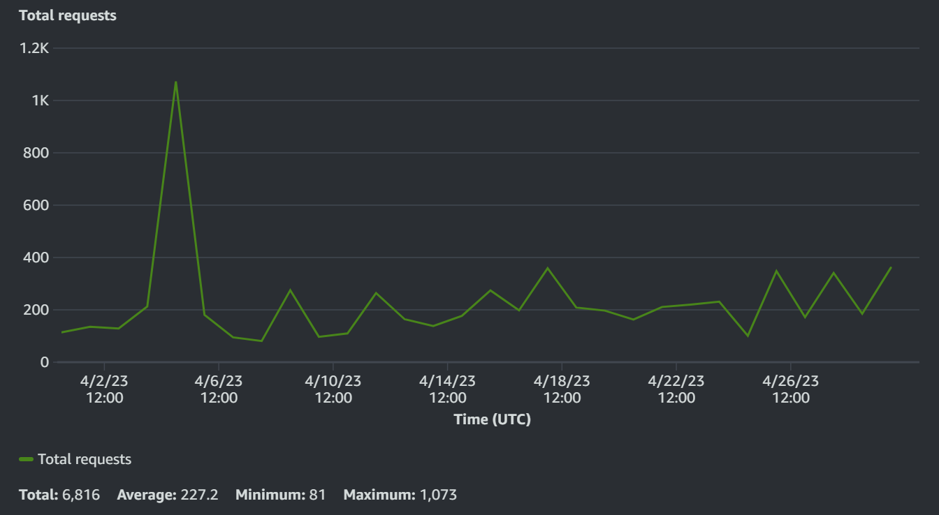

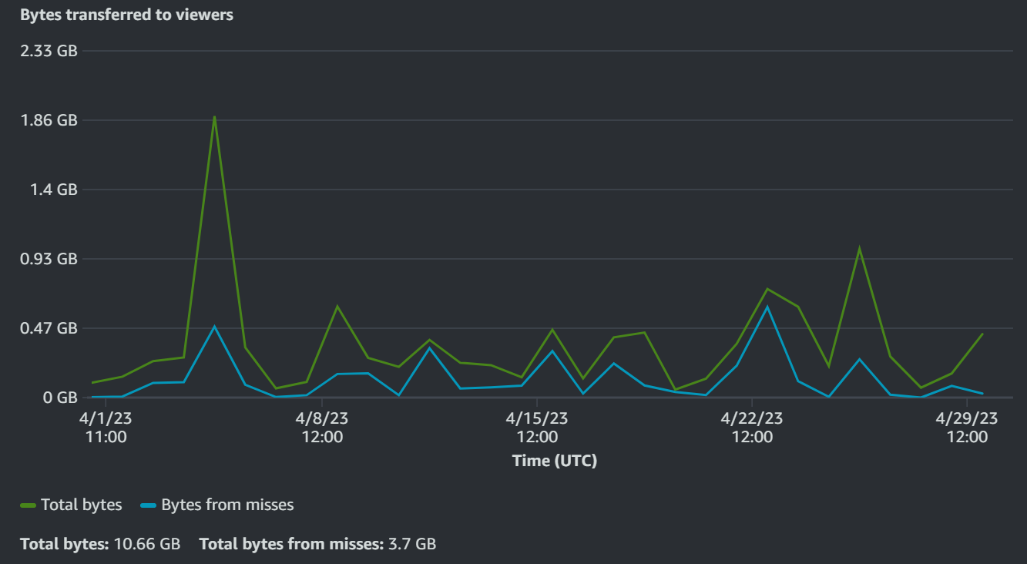

Popular Objects

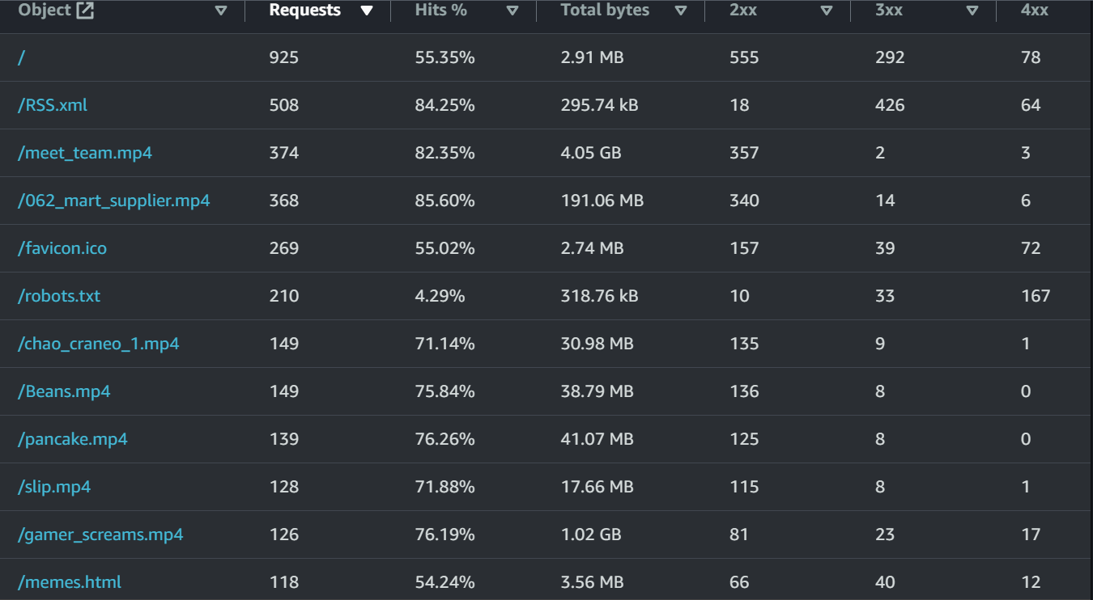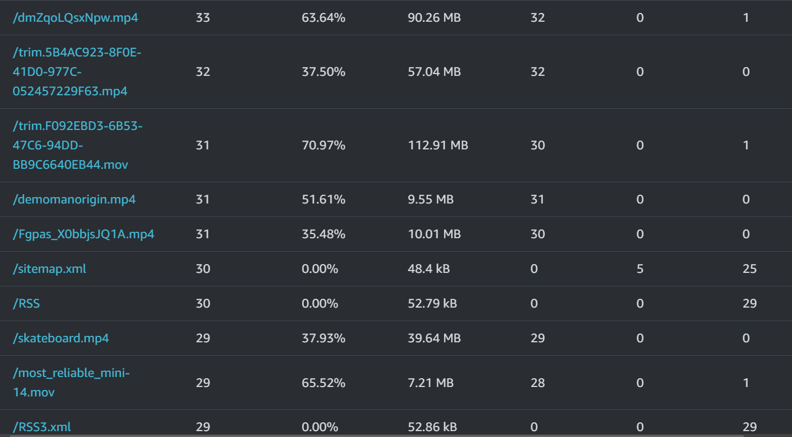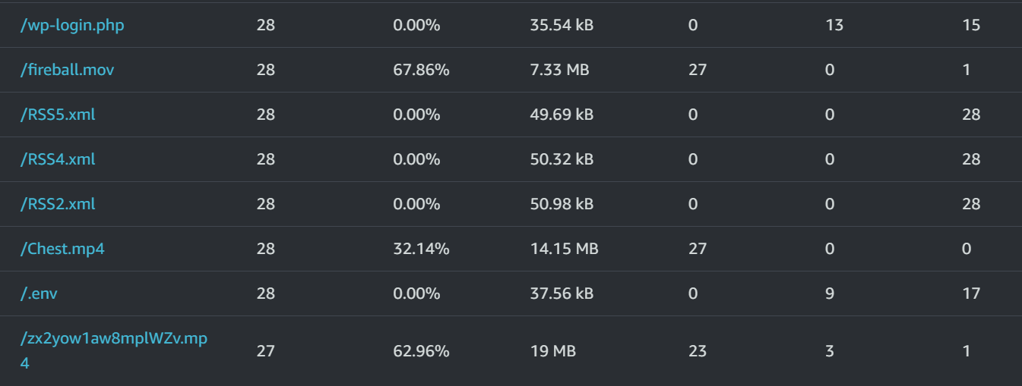

Top referrers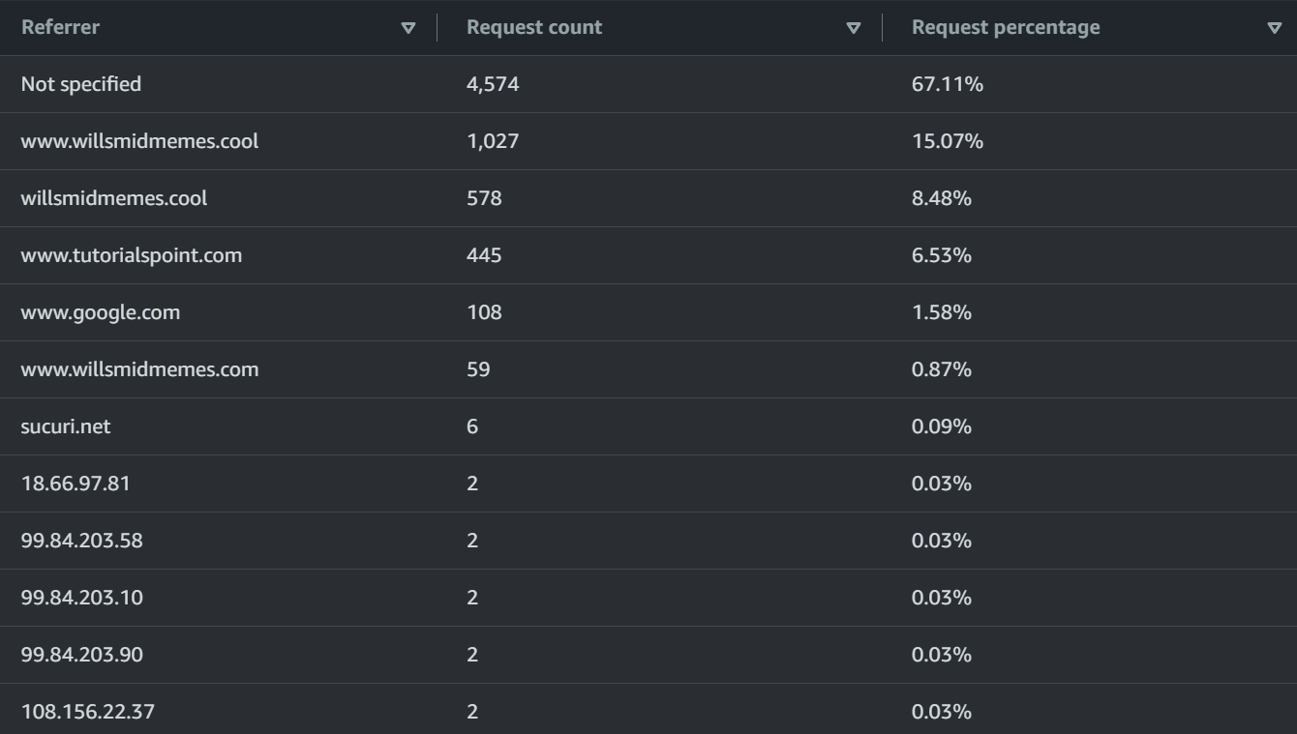

Usage

Viewers

Devices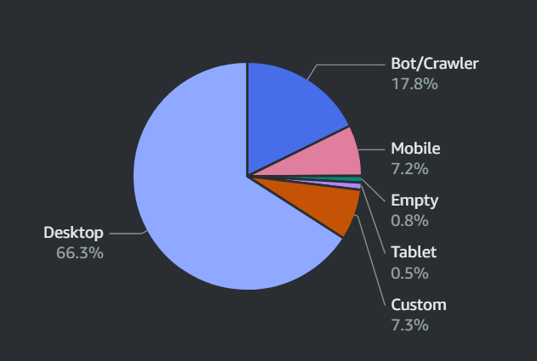

Browsers

Operating Systems

Countries

CloudWatch Statistics

Note:

Each point in Bytes Downloaded is the total bytes downloaded in 1 hour.

Each point in Requests is the total requests in 1 hour.

Each point in First Byte Latency is the average first byte latency in 1 hour.

Each point in Total Latency is the average total latency in 1 hour.

The value of Days Until Certificate Expiry is the average days until certificate expiry in 1 day.

Each point in Storage Space Used is the average storage space used in 1 day.

Each point in Number Of Files is the maximum number of files in 1 day.

Billing Statistics

Total cost

25.84 NZD / 16.12 USD / 12.91 GBP

Up by 2,504.0%

Cost by service

Registrar – 20.84 NZD / 13.00 USD / 10.41 GBP

Route 53 – 1.63 NZD / 1.02 USD / 0.82 GBP

Amplify – 0.00 NZD / 0.00 USD / 0.00 GBP

CloudFront – 0.00 NZD / 0.00 USD / 0.00 GBP

CloudWatch – 0.00 NZD / 0.00 USD / 0.00 GBP

Data Transfer – 0.00 NZD / 0.00 USD / 0.00 GBP

Simple Storage Service – 0.00 NZD / 0.00 USD / 0.00 GBP

Tax – 3.37 NZD / 2.10 USD / 1.68 GBP