**Will’s Mid Memes – May report**

CloudFront statistics

Cache Statistics

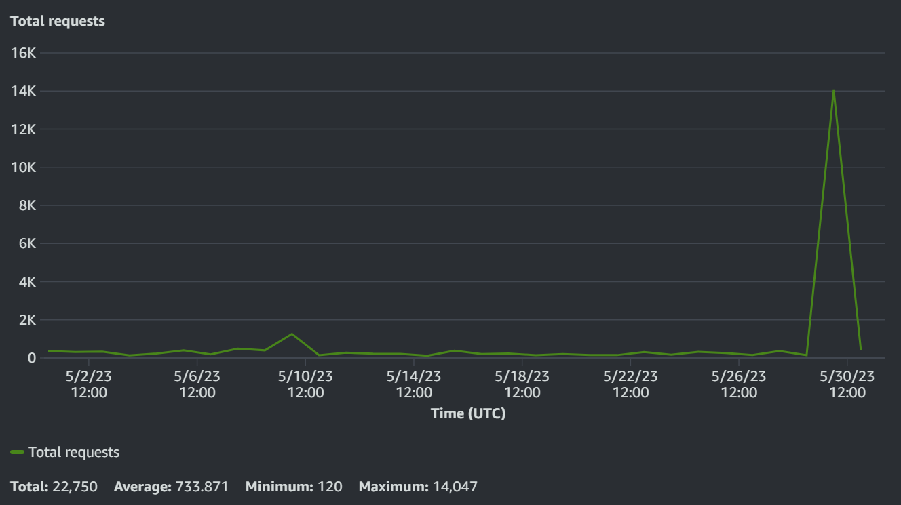

Popular Objects

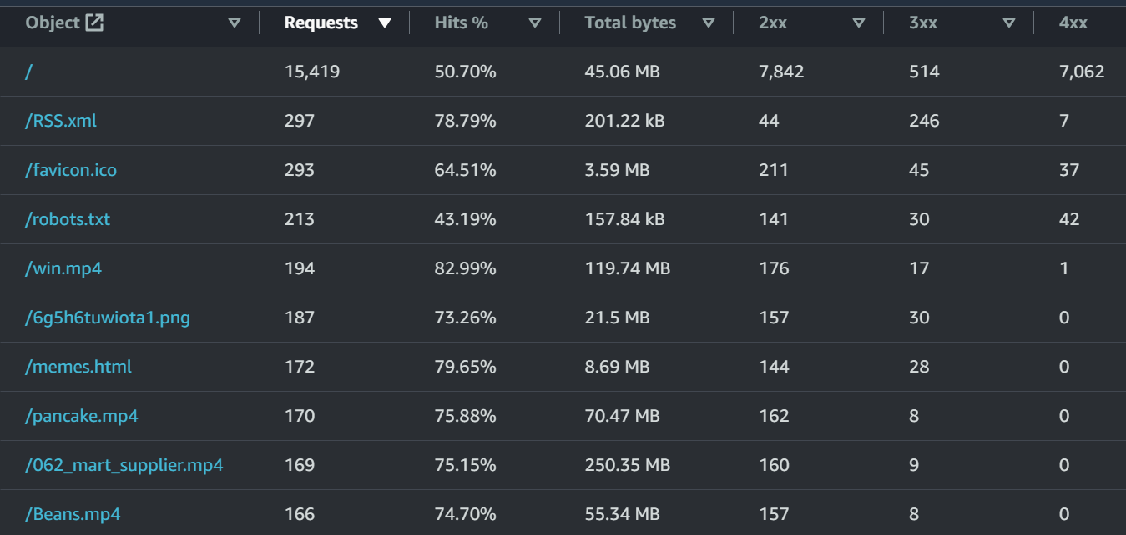

Top referrers

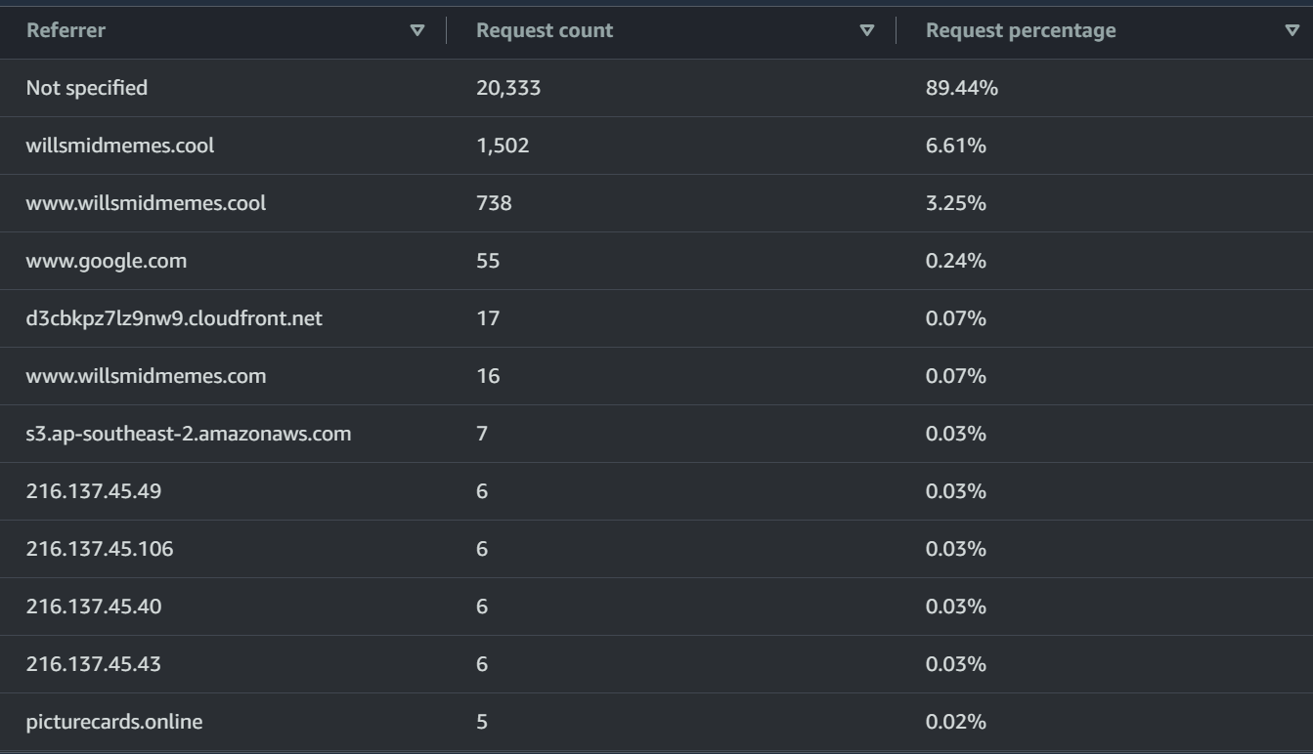

Usage

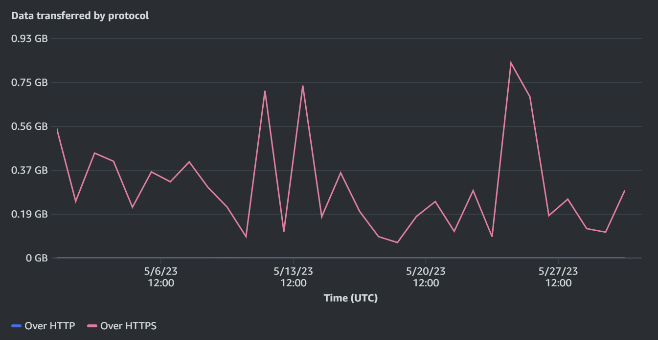

Viewers

Devices

Browsers

Operating Systems

Countries

CloudWatch Statistics

Note:

Each point in Bytes Downloaded is the total bytes downloaded in 1 hour.

Each point in Requests is the total requests in 1 hour.

Each point in First Byte Latency is the average first byte latency in 1 hour.

Each point in Total Latency is the average total latency in 1 hour.

Each point in Allowed Requests is the total requests allowed by WAF in 1 hour.

Each point in Blocked Requests is the total requests blocked by WAF in 1 hour.

The value of Days Until Certificate Expiry is the average days until certificate expiry in 1 day.

Each point in Storage Space Used is the average storage space used in 1 day.

Each point in Number Of Files is the maximum number of files in 1 day.

Billing Statistics

Total Cost

2.26 NZD / 1.36 USD / 1.09 GBP

Down by 91%

Cost by service

Route 53 – 1.66 NZD / 1.00 USD / 0.80 GBP

Web Application Firewall – 0.28 NZD / 0.17 USD / 0.14 GBP

Simple Storage Service – 0.02 NZD / 0.01 USD / 0.01 GBP

Tax – 0.30 NZD / 0.18 USD / 0.14 GBP